Add cover Add comment

**When To Avoid The London Session**

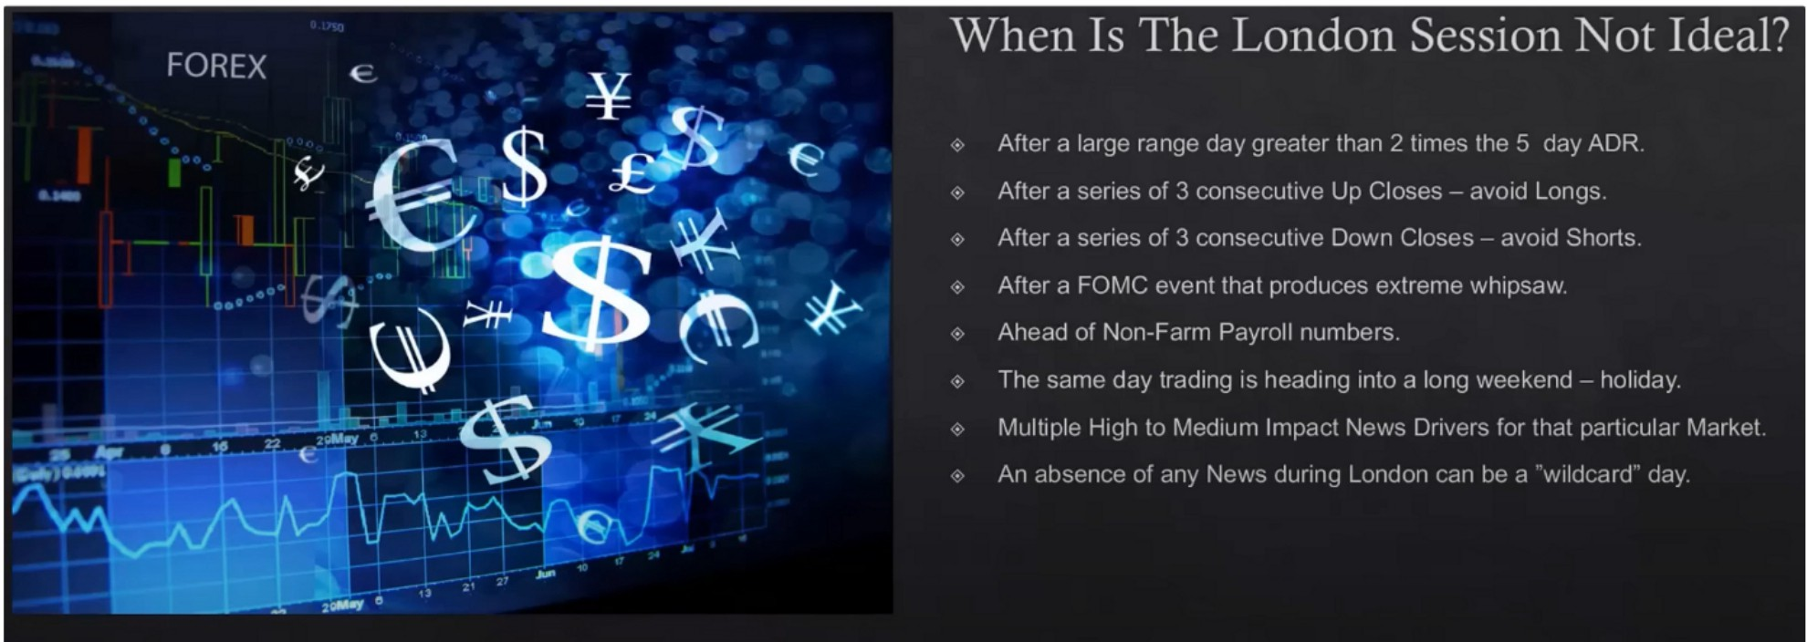

Typically a consolidation or choppy day after a big range day

Avoid longs atleast in the london session after 3 consecutive updays, there will be a pause or a retracement lower

Extreme whipsaw up and down thats going to mess up london

We think in probabilities, we look for the highest probabilities, not every day is high probability Multiple high impact or medium impact news

We ideally want 1 high or medium impact news event per day, 1 stage of manipulation and then the expansion going into new york

Wildcard day means it can go either way, it could be clean but there could also be maybe an unexpected event, a black swan event



When a sustained rally or decline happens from 8pm NY, it usually means it setting up for a poor london session. Usually a retracement will happen at new york, if a retracement happens at all.

Use 15m timeframe to see if CBDR and asia are consolidating or not

When banks are holding price in a small consolidation, it means theyre allowing orders to build above and below the high and low thats formed between the asian range open and asian range close. Thats is exactly what we want, we want to see that building of orders. Thats high probability, with a clear manipulation cycle.

If asia is trending, the London is not high probability

We want to be it high probability, so that means we're not trading everyday.

lntraday is where banks can manipulate and push people out.

We know based on the daily and 4h PD arrays and IPDA data ranges where price will likely draw to, so when we know that we know it will manipulate the other way and then distribute their orders at a PD array in london close

We know what we're looking for, if things are not present then thats not high probability, if you just do something without these conditions and you lose money then you know why.

Dant ignore this lesson

The precision wont be as good when these things are not ideal We have to have filters, we dont trade every single trading day

If you dont have filters and rules youre going to overtrade, yes you might catch a move but in the long term youre not helping yourself and your money



When we see daily chart is clearly respecting PD arrays, then that way we know what our daily bias is. Is it going to be reaching higher or lower. So we have to have a discernable direction in the market place on the daily chart and it has to be respecting a PD array matrix and that way we know what our daily bias is.

When the market is poised to trade higher to a premium array, were going to be looking for london longs. We know on the **HTF** its respecting the PD array matrix and the most likely outcome is that its going to be reaching fo a premium PD array. The range at which price is trading at right now at market price to the next premium PD array, thats going to be indicative of how much we can expect for the next price move higher. It may not fulfill that in 1 day, it can take several days, if the range is still there then we can trade it as well the next day

When we recently came from a premium array and have a discount array to target then London shorts are ideal ofc, we still need all the things from the previous slides

Keep a log of the daily ranges so the 5 day ADR is more clear, this is why you dont want to trade 20 pairs

If a day hasnt exceeded above the 5 day ADR then the next day we can expect an expansion day Dant seek validation by trading every day, stick to these rules

When these big range days happen, thats our cream, thats our bonus We want a smooth equity curve

This is our checklist for if were going to trade London or not

Were going to miss moves when the conditions are not ideal, and thats fine. We look for the highest probability and the easiest days. ICT doesnt trade everyday

This is a lesson that helps you build a winners mindset

You have to have rules, the best rules are that help you stay out of the marketplace, because everyone can get in the marketplace. Anyone can come up with a reason to participate in the marketplace. We want to know the reasons when to stay out of the marketplace, and thats what this lesson has given

Position trading, swing trading, day, short term or scalping, it doesnt matter, this criteria will help with any single one of the models. Because if youre executing in London and it doesn fit the criteria then you want to wait, wait for a better enviroment and when you get then take the entry with much more confidence. be in the market when its in your favor.

If we cant see clearly when the protractionary state is happening and when the manipulation is happening, then what are we doing in the marketplace? Then its gambling, gamblers make money sometimes, but they dont make a living

Homework: make your own checklist out of this lesson, and write it out

Arjo I Twitter, lnstagram I Linktree

Linktree. Make your link do more.

1 https://t.co/HhmmTN1fUI

JavaScript is not available.

"# https://twitter.com/arjoio